**READING LESSON GUDE FOR BABY CLASS 3 – 4 YRS TERM ONE 2023**

**WEEK ONE ( ORIENTATION**

**Activities**

* Touring the school
* Knowing each other
* Taking care of property
* Playing from the swings , sand , watching T.V etc

**WEEK TWO ( 2)**

**THEME (Sounds)**

**LESSON 1**

Sound (**s**)

**Activities**

* Listening to the story line of the sound
* Observing sound **(s)** and its formation
* Saying sound **‘s’**
* Doing the actions
* Naming pictures of sounds **‘s’**
* Pasting sound **‘s’**

**LESSON 2**

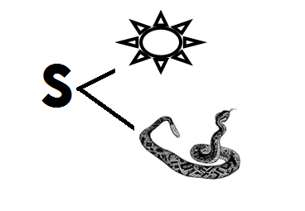**Activities**

* Shading sound ‘s’ and the pictures
* Saying sound ‘s’ with the action
* Naming pictures of sound ‘s’

**Lesson 3**

Sound ‘s’

**Activities**

* Sound with the action
* Naming pictures of the sound
* Tracing sound

**WEEK 2**

**LESSON 4**

Sound ‘ **a** ‘

**Activities**

* Listening to the story line of the sound.
* Observing the sound
* Sounding with the actions
* Naming the pictures of he sound
* Pasting the sound ‘**a**’

**WEEK 3**

**LESSON 1**

Sound ‘**a**’

**Activities**

* Shading sound ‘**a**’ and the pictures
* Sounding with the actions
* Naming pictures of sound ‘**a**’

**LESSON 2**

Sound ‘**a**’

**Activities**

* Sounding with actions
* Naming picture of sound ‘**a**’
* Sorting
* Tracing sound ‘**a**’



**WEEK 3**

**LESSON 3**

**THEME** : Sounds ( **s** and **a**)

**Activities**

* Saying the sounds with actions
* Naming pictures of the sounds
* Sorting
* Matching the same pictures

[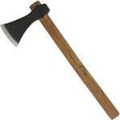](http://www.google.com/imgres?imgurl=http://www.medieval-weaponry.co.uk/acatalog/XH2042N-1000.jpg&imgrefurl=http://www.medieval-weaponry.co.uk/acatalog/throwing-axe.html&usg=__hcCiW4qOAlCEG01PQbkJHWk8kyE=&h=1000&w=1000&sz=88&hl=en&start=11&zoom=1&tbnid=OcFrTXk0M7IZCM:&tbnh=149&tbnw=149&ei=B2LvUf7CF5C1hAeRm4HQDQ&prev=/search?q=AXe&hl=en&gbv=2&tbm=isch&itbs=1&sa=X&ved=0CEAQrQMwCg)

[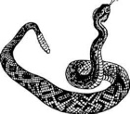](http://www.bing.com/images/search?q=www.google+image+snake+&view=detail&id=B2F20F56F4B4857DF3EAA13F83ADEB5B696F5EA0&first=0&FORM=IDFRIR)

[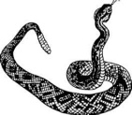](http://www.bing.com/images/search?q=www.google+image+snake+&view=detail&id=B2F20F56F4B4857DF3EAA13F83ADEB5B696F5EA0&first=0&FORM=IDFRIR)

[](http://www.google.com/imgres?imgurl=http://www.medieval-weaponry.co.uk/acatalog/XH2042N-1000.jpg&imgrefurl=http://www.medieval-weaponry.co.uk/acatalog/throwing-axe.html&usg=__hcCiW4qOAlCEG01PQbkJHWk8kyE=&h=1000&w=1000&sz=88&hl=en&start=11&zoom=1&tbnid=OcFrTXk0M7IZCM:&tbnh=149&tbnw=149&ei=B2LvUf7CF5C1hAeRm4HQDQ&prev=/search?q=AXe&hl=en&gbv=2&tbm=isch&itbs=1&sa=X&ved=0CEAQrQMwCg)

**Lesson 4**

Sound ‘ **t**’

**Activities**

* Listening to the storyline
* Observing sout **‘ t ‘**
* Naming the pictures
* Sounding with the action
* 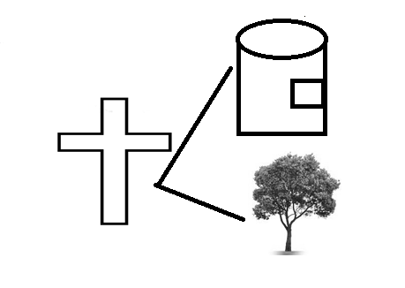Shading sound **‘t’**

**WEEK 4**

**LESSON 1**

Sound **‘t’**

**Activities**

* Saying sound **‘t’**
* Doing the action of sound **‘t’**
* Naming the pictures of sound **‘t’**
* Tracing

**LESSON 2**

**Activities**

* Saying sound ‘**t**’ with action
* Naming the pictures of the sound
* 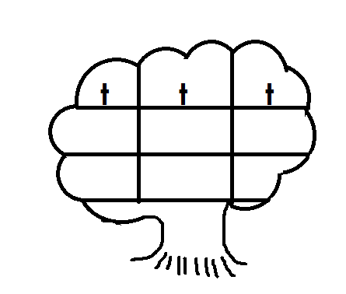Writing sound **‘t’**

**LESSON 3 (sounds)**

**Activities**

* Sounding with actions
* 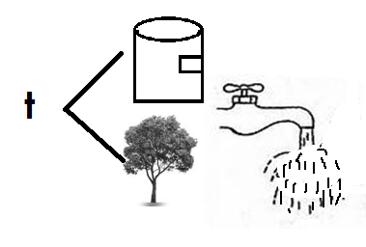Naming pictures
* Sorting
* Shading the picture sound ‘ **t** ‘

WEEK 4

LESSON 4

Sounds ( **s , a , t** )

Activities

* Sounding with actions
* Sorting
* Naming pictures of sounds
* Matching the same sounds

s t

a s

t a

**WEEK FIVE**

**LESSON 1**

Sound **‘ i ‘**

Activities

* Listening to the storyline of the sound ‘**i’**
* Saying sound **‘ i ‘** with the action
* Naming pictures of sound **‘i’**

**LESSON 2 ( sounds satipn)**

**Activities**

* Sounding with actions
* Naming picture of sound **‘ i ‘**
* Shading sound **‘i’** with pictures

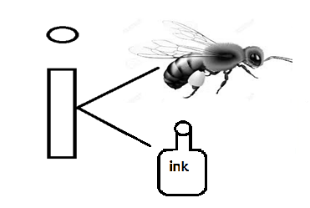

**WEEK FIVE**

**LESSON 3 (sounds satipn)**

**Activities**

* Recognising the formation of sound **‘i’**
* Naming its pictures
* Saying the sound with action
* Writing sound **‘i’**

|  |  |  |
| --- | --- | --- |
| i | i | i |
|  |  |  |
|  |  |  |

**LESSON 4**

Sound **P**

**Activities**

* Listening to the storyline
* Saying the sound with the actions
* Naming the pictures of sound **‘P’**

**WEEK SIX**

**LESSON 1 (sounds satipn)**

**Activities**

* Sounding with the actions
* Sorting
* Matching
* Naming picture
* Shade

**WEEK SIX**

**LESSON 2 (sounds saptin)**

**Activities**

* Sounding with actions
* Recognising the learnt sound ( satip)
* Naming pictures of sounds
* 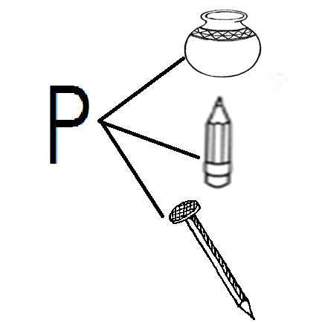Shading pictures of sound ‘p’

**LESSONS 3 (sounds satipn)**

**Activities**

* Recognising the formation of sound **‘P’**
* Sounding with the action
* Naming pictures of sound **‘P’**
* 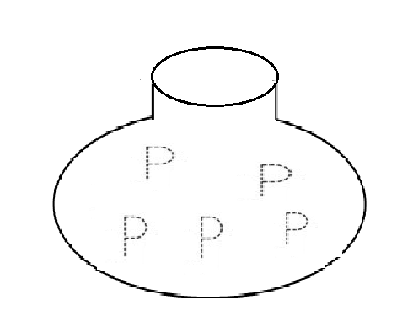Tracing sound **‘P’**

**WEEK SIX**

**LESSON 4 (sound satipn)**

**Activities**

* Sorting
* Sounding with actions
* Naming pictures of different sounds
* Matching a sound to picture

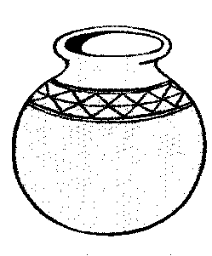

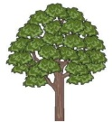s

a

t

p

**WEEK SEVEN**

**LESSON 1 (sounds satipn)**

**Activities**

* Identifying sounds
* Naming sounds and their pictures
* Doing different actions
* 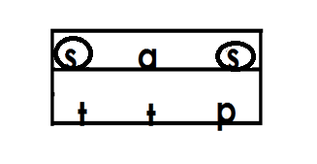Circling the same sounds

**WEEK SEVEN**

**LESSON 2 (sound satipn)**

**Activities**

* Listening to the storyline of sound ‘n’
* Saying sound ‘n’
* Doing the action of sounds
* Naming the pictures of sound **‘n’**

**LESSON 3**

**Activities**

* Recognising sound ‘n’
* Sounding with the action
* Naming pictures of sound ‘n’
* 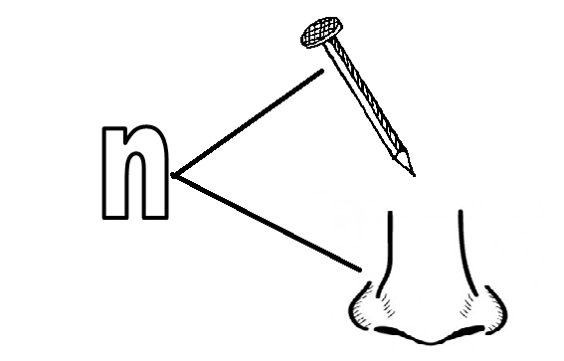Shading

**LESSON 4 (sounds satipn)**

**Activities**

* Saying sound ‘n’ with the action
* Naming the pictures
* Tracing sound ‘n’
* Tracing sound ‘n’

**WEEK EIGHT**

**LESSON 1 (sounds satipn)**

**Activities**

* Identifying sounds
* Naming pictures of sounds
* Matching the same sounds

s n

a p

t s

i a

p i

n t

**LESSON 2 (sounds satipn)**

**Activities**

* Recognising sounds
* Naming different pictures
* Shading the same pictures

[](http://www.bing.com/images/search?q=www.google+image+snake+&view=detail&id=B2F20F56F4B4857DF3EAA13F83ADEB5B696F5EA0&first=0&FORM=IDFRIR)

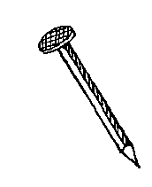

**LESSON 3 (sounds satipn)**

**ACTIVITIES**

* Sounding with actions
* Sorting
* Circling the given pictures

|  |  |  |
| --- | --- | --- |
|  |  |  |
|  |  |  |

**WEEK EIGHT**

**LESSON 4 (sounds satipn)**

**Activities**

* Sounding sounds with their actions
* Sounding with actions
* Circling the given pictures

|  |  |  |
| --- | --- | --- |
| s | a | s |
| t | t | n |
| i | p | i |